**Zomato Spreadsheets Project: Documentation Component**

* **Objective Questions**

1. *What is the total no. of tables present in the data?*

Two [Originally].

1. *What is the total no. of attributes present in the data?*

24 attributes.

1. *How many categorical columns are there in the data? [Search about categorical and continuous data, and try to answer this question]*

Categorical columns refer to a type of data that represents categories or labels. These columns contain a finite number of distinct categories or groups. Categorical data is qualitative in nature.

As such, the categorical columns in the data include the following twelve:

RestaurantName, CountryCode, Country, City, Locality, LocalityVerbose, Cuisines, Has_Table_booking, Has_Online_delivery, Is_delivering_now, Switch_to_order_menu, Price_Range

1. *The data consists of some inconsistent and missing values so ensure that the data used for further analysis is cleaned.*

[Executed in spreadsheet]

1. *Using the LookUp functions, fill up the countries in the original data using the country code.*

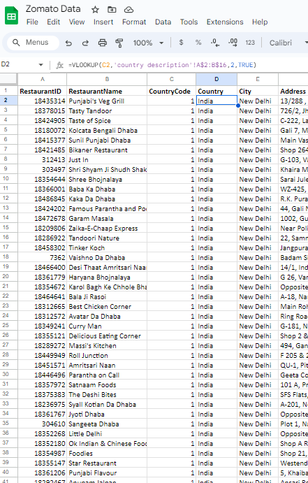

1. *Create a table to represent the number of restaurants opened in each country.*

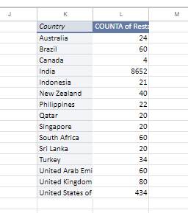

1. *Also, the management wants to look at the number of restaurants opened each year, so provide them with something here.*

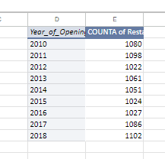

1. *What is the total number of restaurants in India in the price range of 4?*

There are 388 India-based restaurants with the price range of 4.

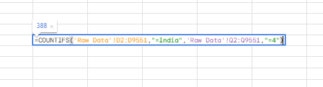

1. *What is the average number of voters for the restaurants in each country according to the data?*

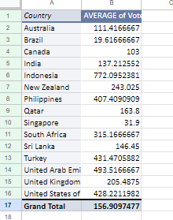

1. *Calculate the average rating for all the restaurants that have price range < 4 and provide online delivery. Use only the “IF” function, Logical Operators, and Aggregation functions to solve this problem.* ***[Note: Don’t use Conditional aggregation in this question.]***

By inserting a new column within the Raw Data that omits ratings for restaurants that fail the aforementioned conditions, we use the following formula to arrive at the average rating for the rest of the restaurants:

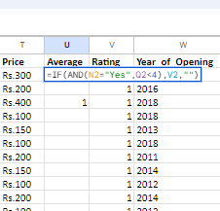

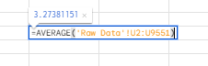

3.27381151

1. *Using Conditional formatting highlight the rows of restaurants that are located in the countries or cities that you’ve suggested to the management for opening new restaurants.*

[Executed in Spreadsheet]

1. *Create a new customized price column that consists of the abbreviation/symbol of the currency along with the Average_cost_for_two value. [Use string operations to do this task]*

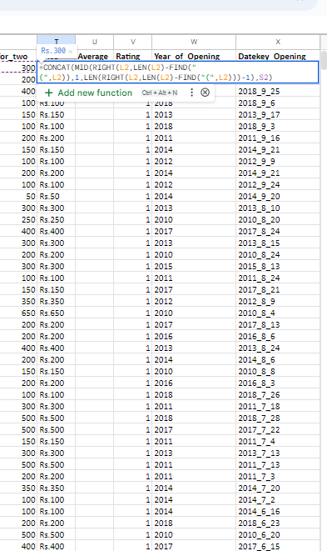

1. *How can you create an array formula in Excel or Google Sheets to count the number of restaurants listed that do not offer online delivery, are in the lowest price range, and have an average cost for two people less than or equal to 250 Indian Rupees?*

=COUNTIFS('Raw Data'!Q2:Q9551,"=1",'Raw Data'!N2:N9551,"=No",'Raw Data'!S2:S9551,"<=250"),

which evaluates to 1834 such restaurants.

* **Subjective Questions**

1. *Suggest a few countries where the team can open newer restaurants with lesser competition. Which visualization/technique will you use here to justify the suggestions?*

Of the countries considered within the spreadsheet, Canada appears a particularly attractive host for new restaurants. A pivot table populated with countries in the rows and, in the columns, their respective count of restaurants offering online-delivery, unambiguously reveals Canada to be the most lacking country. For the same reason, other suggestions include Australia, Philippines, Qatar, Indonesia, Singapore and Sri Lanka.

1. *Come up with the names of States and cities in the suggested countries suitable for opening restaurants.*

* Australia – Virtually every Australian city mentioned in the spreadsheet (except Hepburn Springs) has a single restaurant. All of these are therefore suitable for opening new restaurants.
* Philippines – Quezon and Tagaytay cities also have a single restaurant apiece. The two restaurants in Santa Rosa fare worse, ratings-wise, than those in other cities. Newer restaurants here would likely face lesser competition.
* Canada – The reaturants in Yorkton and Chatham-Kent strike a balance between relatively higher customer traffic and poorer ratings, hinting at favorable conditions for newcomers.

1. *According to the countries you suggested, what is the current quality regarding ratings for restaurants that are open there?*

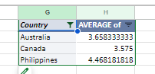

As seen above, the average rating of each country’s restaurants is:

* Australia – 3.66
* Philippines – 4.47
* Canada – 3.57

1. *Also, what is the current expenditure on food in the suggested countries, so we can keep our financial expenditure in control?*

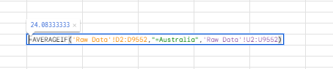

Using the AVERAGEIF function, as above, for each country gives us the following mean prices-for-two across their respective restaurants:

* Australia - $24.08
* Philippines – P1606.81
* Canada – $36.25

1. *Come up with the names of restaurants from the recommended states that are our biggest competitors and also those that are rated in the lower brackets, i.e. 1-2 or 2-3.*

A list of Canadian, Australian and Philippian restaurants with glowing ratings and lower price ranges would offer the stiffest competition. Such restaurants were identified via filter views on the Raw Data, and some of them are:

* Silantro-Fil-Mex (Philippines, Rating 4.9, Price Range 3)

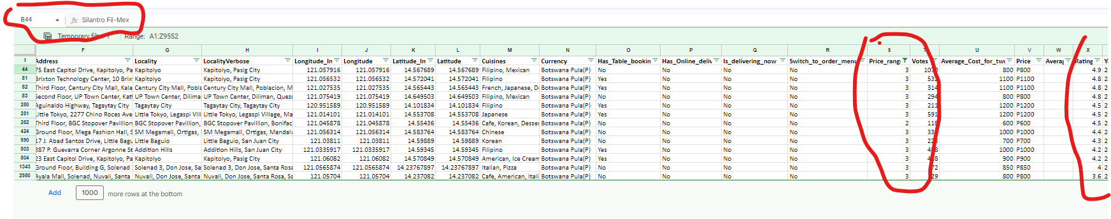

* Bridge Road Brewers (Australia, Rating 4.6, Price Range 2)

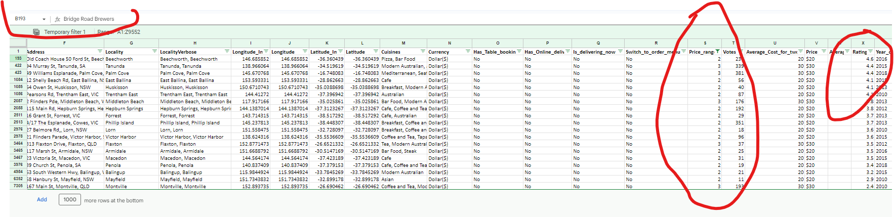

* Tokyo Sushi (Canada, Rating 3.7, Price Range 2)

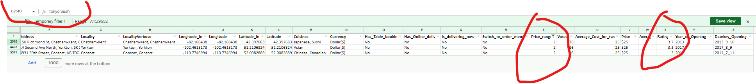

1. *Which cuisines should we focus on in the newer restaurants to get better feedback? Does the choice of cuisines affect the restaurant ratings?*

A pivot table of cuisines against ratings shows that the best ratings were awarded to restaurants that serve World Cuisine, Italian, European, Mexican and Seafood.

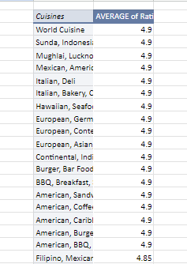

As seen above, the types and combinations of cuisine offerings and ratings are indeed correlated.

1. *According to our current data, should we go for online delivery and table booking? Does that affect the customer’s ratings?*

Yes, these two boolean metrics affect customer ratings. Unavailability of online delivery or table booking adversely impacts ratings, such that the average of such restaurants is 2.68. On the other hand, this value for restaurants with both capabilities is 3.6. It is therefore strongly advisable that newer restaurants opt for providing both these services.

1. *Should the team keep the rate of cuisines higher? Will that affect the feedback? According to our data are the rates of cuisines and ratings, correlated?*

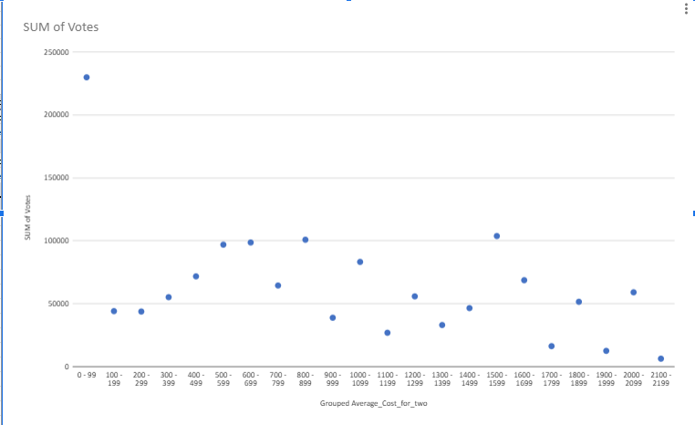

Yes, we can see from the above scatterplot that feedback grows more positive with average cost for two up until Rs. 600, after which the trend is roughly negative, aside from abrupt surges around the Rs 800-1100 range and again at the 1500-1600 range, perhaps indicating a difference concerning customer affluency and how much they prefer spending when dining out.

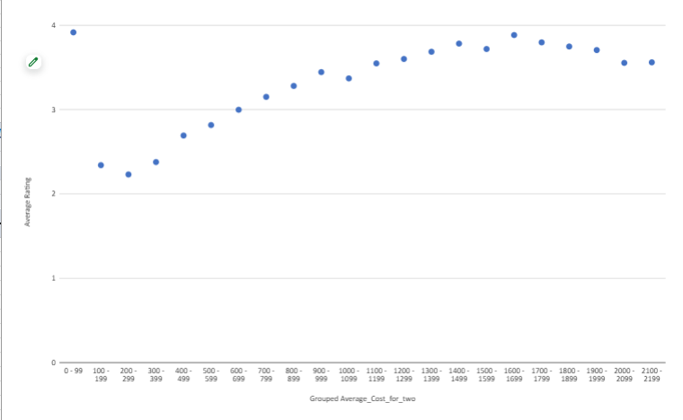

Similarly, in this scatterplot, restaurants show consistent uptick in ratings as their prices increase up until the Rs. 1700 mark, followed by a marginal decline. This appears to support the conclusion of pricier restaurants offering better quality dining.

1. *What is the distribution of the number of restaurants of different price ranges in all the countries?*

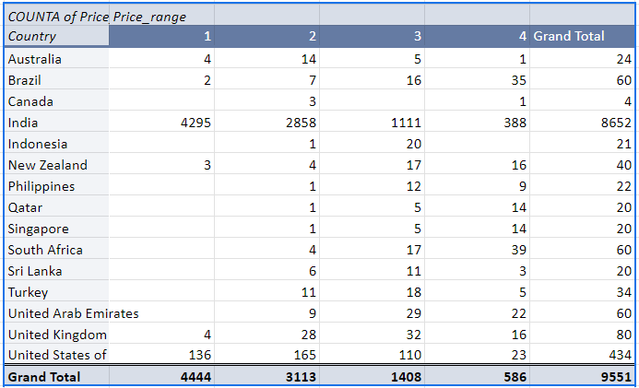

1. *Explain your approach in brief for suggesting countries/cities in order to open new restaurants, if the objective and subjective questions would have not been given to assist you.* ***[you have to give bullet pointers in order to answer this question]***

* I would utilize filtering & sorting on multiple columns to highlight which country’s restaurants tend to stand out with respect to differing factors.
* Also, I’d play around with pivot tables of my own choosing by trying as many pairs of the given metrics as possible. The use of dynamic charts based on these tables would surely lead to core insights about specific countries as well as all regions taken as a whole.